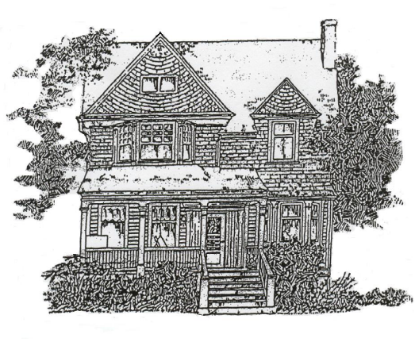 | Seeking the peace of the city through intentional Christian community
 | Reba Place Fellowship, Inc.  737 B Reba Place  Evanston IL 60202 | Ph. 847-328-6066  Fax 847-328-8431 rebafellowship@gmail.com

REBA PLACE FELLOWSHIP INTERN/NEWCOMER INFORMATION SHEET

Date:
Name:______________________________________________________________________________________
Current Mailing Address:______________________________________________________________________
City:_______________________________________ State: _________ Zip Code: _________________________
Phone(s):___________________________ Email:___________________________________________________
Birthdate: ___________________ Age:______________
Marital Status: ______ Single _______ Married ______ Divorced
Church affiliation: Are you a church member? __________________
If yes, where? _________________________________________________________________________
If no, do you regularly attend somewhere?__________________________________________________
Education: Last Grade of Education Completed: ___________________________________________________

Work: Current position and employer:_____________________________________________________________
Summary of previous work experience: ______________________________________________________
______________________________________________________________________________________
______________________________________________________________________________________

Health: Please let us know if you have any ongoing health issues that may affect your participation (attach additional page if necessary):

Medical conditions: ______________________________________________________________________
Medications taken: _____________________________________________________________________
Physical or mental disabilities ______________________________________________________________
Food restrictions/allergies: _______________________________________________________________
Any history of addiction: _________________________________________________________________
Limits to your ability to perform manual labor: _______________________________________________
_____________________________________________________________________________________
Other/Additional notes: ________________________________________________________________
____________________________________________________________________________________

Getting to know you: Please attach responses to the following questions. Write at least a paragraph, but no more than a page, for each question.

- What's your story? When did you begin following the way of Jesus?
- What has your relationship with God been like since then?
- What draws you to community?
- Describe your previous experiences with corporate living.
- What practices/ activities of Reba Place Fellowship are you drawn to?
- What would you consider to be your personal strengths and weaknesses? What comes easily to you? What do you find challenging?
- What keeps your life enjoyable? What interests you?
- What are your hopes and expectations for the time you spend with us?
- (For intern applicants) Describe your experiences relevant to the positions you are applying for.
- (For intern applicants) When could you start this internship?

Personal references: Please list contact information for two people who know you well. Please do not list relatives, and include at least one person who is not a peer/friend, but is a mentor/ pastor/ employer, etc.
1. Name:_____________________________________________________________________________
Address: ___________________________________________________________________________
Phone: ____________________________________________________________________________
Email: _____________________________________________________________________________
How long known? _________ In what capacity/relationship? ________________________________

2. Name:_____________________________________________________________________________
Address: ___________________________________________________________________________
Phone: ____________________________________________________________________________
Email: _____________________________________________________________________________
How long known? _________ In what capacity/relationship? ________________________________

We ask that people interested in participating in Reba Place Fellowship contact David Hovde (davidahovde@gmail.com) to schedule a visit to RPF. Plan to spend several days to get a better idea of what life is like here before making a decision to move here. Intern candidates need to have an in-person interview with the RPF Intern Committee during their visit. All intern candidates must be willing to have a background check.

Please read the article: “The Way of Love”, by John W. Miller, one of the founders of Reba Place Fellowship. The article can be found here: http://www.rebaplacefellowship.org/resources/rpf-literature/the-way-of-love/
This is an excellent description of the founding vision of Reba Place Fellowship that continues to inspire us.

